Rules for Preschool and Kindergarten Soccer

All players play half the game. All games ending in a tie remain as a tie. No shootouts will be carried out until middle school or high school level.

The philosophy behind the small-sided game:
1: The most important philosophy at this age is that players should be encouraged to HAVE FUN and express themselves!

2: Winning is not the sole objective and should not be placed ahead of the development of the player

3: We need to remember that kids at this age are nowhere near the finished product, and their development process is a long way from being completed.

Objectives:
• Fewer players on the field mean more touches on the ball and more involvement in the game, which helps develop more individual skills.
• The small-sided game helps develop necessary motor skills such as walking, running, and changing direction.
• A smaller space will help develop these skills, also providing more interaction with the ball, teammates, and opponents.

Ball Size:3
Field Size is 20x30 yards (60x90 ft)
One Referee at this age
No Goalie
Number of players on the field is 4
Game Length: at this age, we will play 4 (10) minute quarters with a 1-minute water break after each quarter. Halftime will be 5 minutes.

Rules:
- Kickoff: Start of play at the beginning of the game and the beginning of each quarter will start from the center X. Each team will alternate who will begin play from this spot after each quarter. Resuming play after a goal will also enter from the center X
- Sideline out of bounds: Throw in. (Ball held with two hands all the way behind the head, both feet must remain on the ground as the ball is thrown into play.) Please teach the correct form when done incorrectly.
- End line out of bounds: (Last touched by an offensive team is a GOAL KICK. Any player on the defensive team places the ball at the top of the goal box and kicks it into play.
- End line out of bounds (Last touched by a defensive team is a CORNER KICK. Any player on the offensive team places the ball on the corner of the field that the ball went out on and kicks the ball into play toward the goal they are trying to score on.
- Hands: Results in a FREE KICK. Set the ball where the child touched it and have the opposing team kick it into play.
- No man's land: No one can touch the ball while inside the arc. A ball shot inside the arc will be a goal kick. A blocked shot while standing inside the arch gives the opposing team a goal. If the ball stalls in the arc, it is a goal kick!
- Substitution: Players may be subbed in at any ball out of bounds (GOAL KICK, THROW IN) We suggest subbing approximately every 4 minutes.
- Build outline: The building outline is used to promote playing the ball out of the back in an unpressured setting. When a player has the ball during a goal kick, the opposing team must move behind the build-out line. Once the ball is put into play, the opposing team can then cross the build-out line, and play can resume as normal.
- Equipment: Shin Guards are required. Cleats are optional. Jerseys will be distributed by each city's rec director.
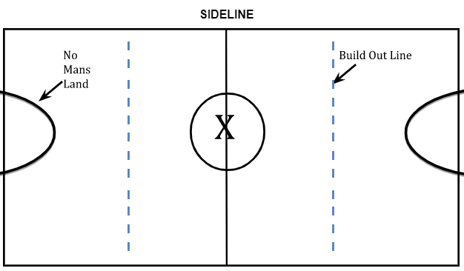

If you have any questions or concerns, please do not hesitate to contact Brandon LeFevre 435-851-3954.

